SQL Report – PostgreSQL Sales Dataset

M TAZEEM SAJID

Step 1: Create Database

I created database name as “Sales Data” in PostgreSQL

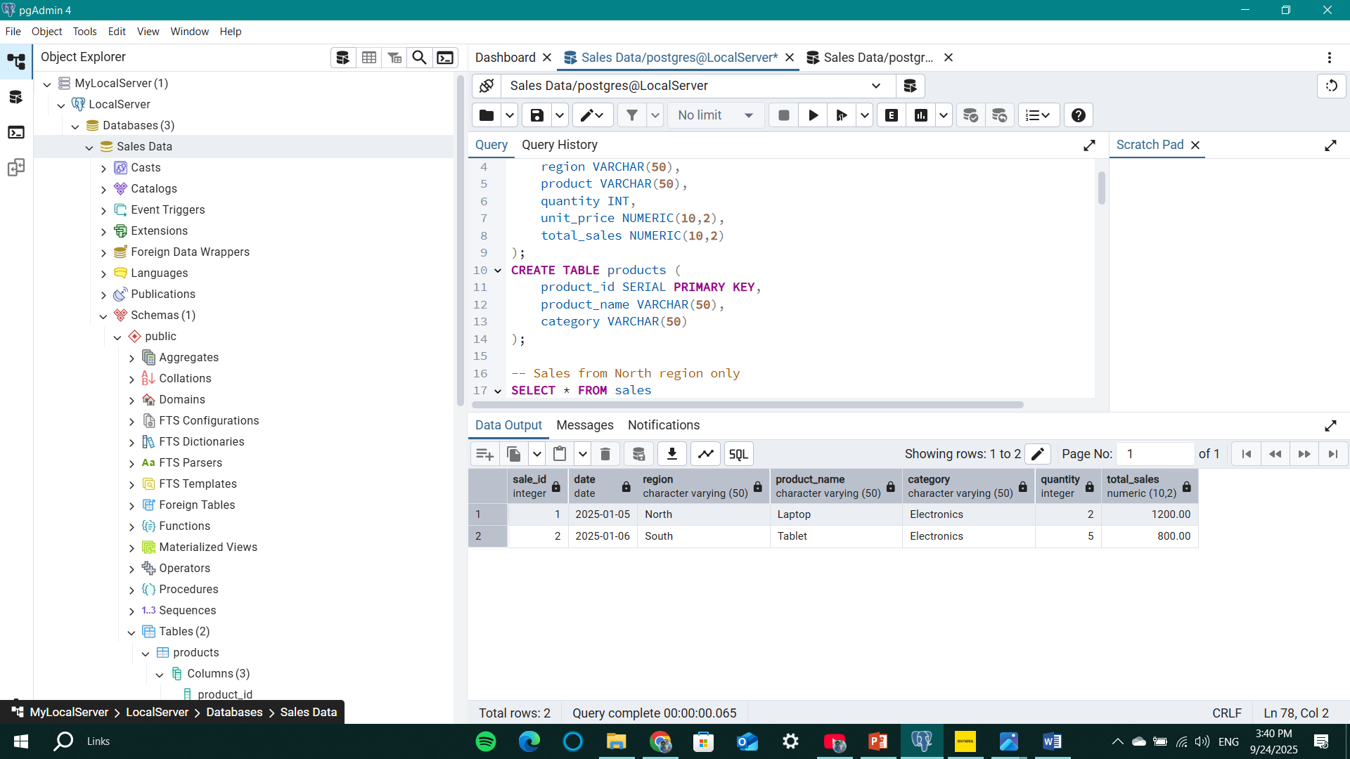

Step 2: Create Tables
-- Sales Table
CREATE TABLE sales (
sale_id SERIAL PRIMARY KEY,
date DATE,
region VARCHAR(50),
product VARCHAR(50),
quantity INT,
unit_price NUMERIC(10,2),
total_sales NUMERIC(10,2)
);

-- Products Table
CREATE TABLE products (
product_id SERIAL PRIMARY KEY,
product_name VARCHAR(50),
category VARCHAR(50)
);
Two tables were created:
  - sales → stores sales transactions.
  - products → stores product details.
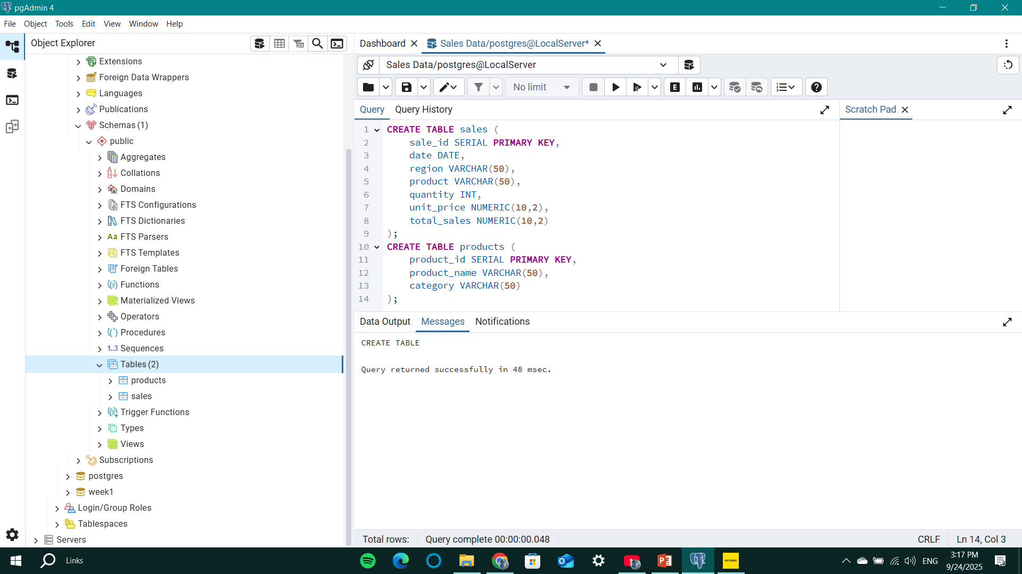

Step 3: Insert Records
INSERT INTO sales (date, region, product, quantity, unit_price, total_sales)
VALUES
('2025-01-05', 'North', 'Laptop', 2, 600.00, 1200.00),
('2025-01-06', 'South', 'Tablet', 3, 200.00, 600.00),
('2025-02-01', 'East', 'Smartphone', 5, 300.00, 1500.00);

INSERT INTO products (product_name, category)
VALUES
('Laptop', 'Electronics'),
('Tablet', 'Electronics'),
('Smartphone', 'Electronics');
Records inserted successfully into both tables.Step 4: Fetch Data with Conditions
-- Sales from North region
SELECT * FROM sales
WHERE region = 'North';

-- Sales above 1000
SELECT * FROM sales
WHERE total_sales > 1000;
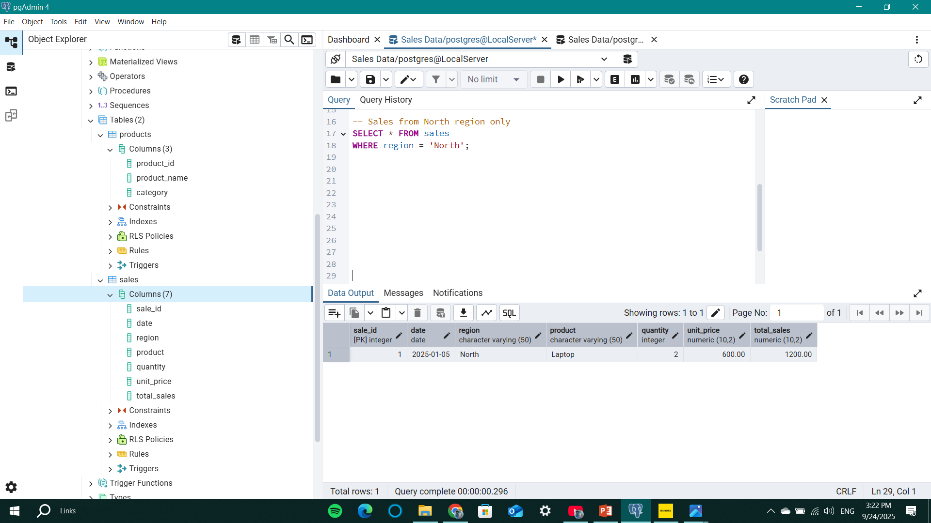
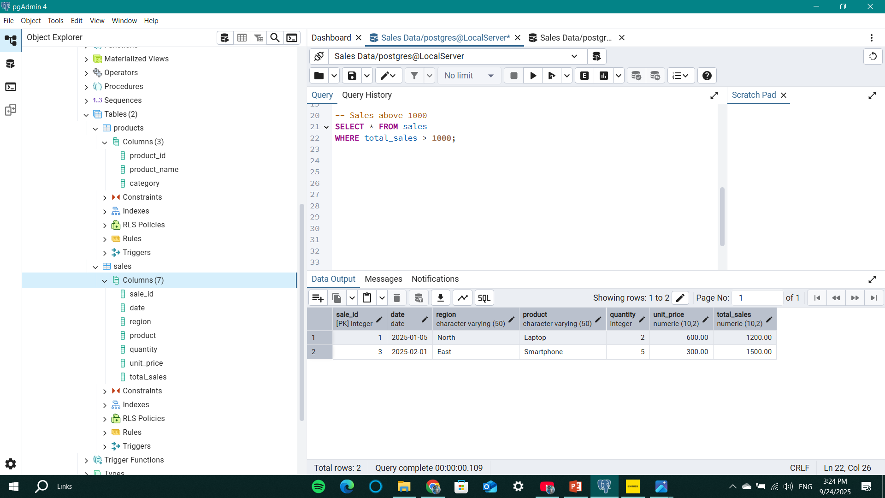

Step 5: ORDER BY
-- Order by sales descending
SELECT * FROM sales ORDER BY total_sales DESC;

-- Order by date ascending
SELECT * FROM sales ORDER BY date ASC;
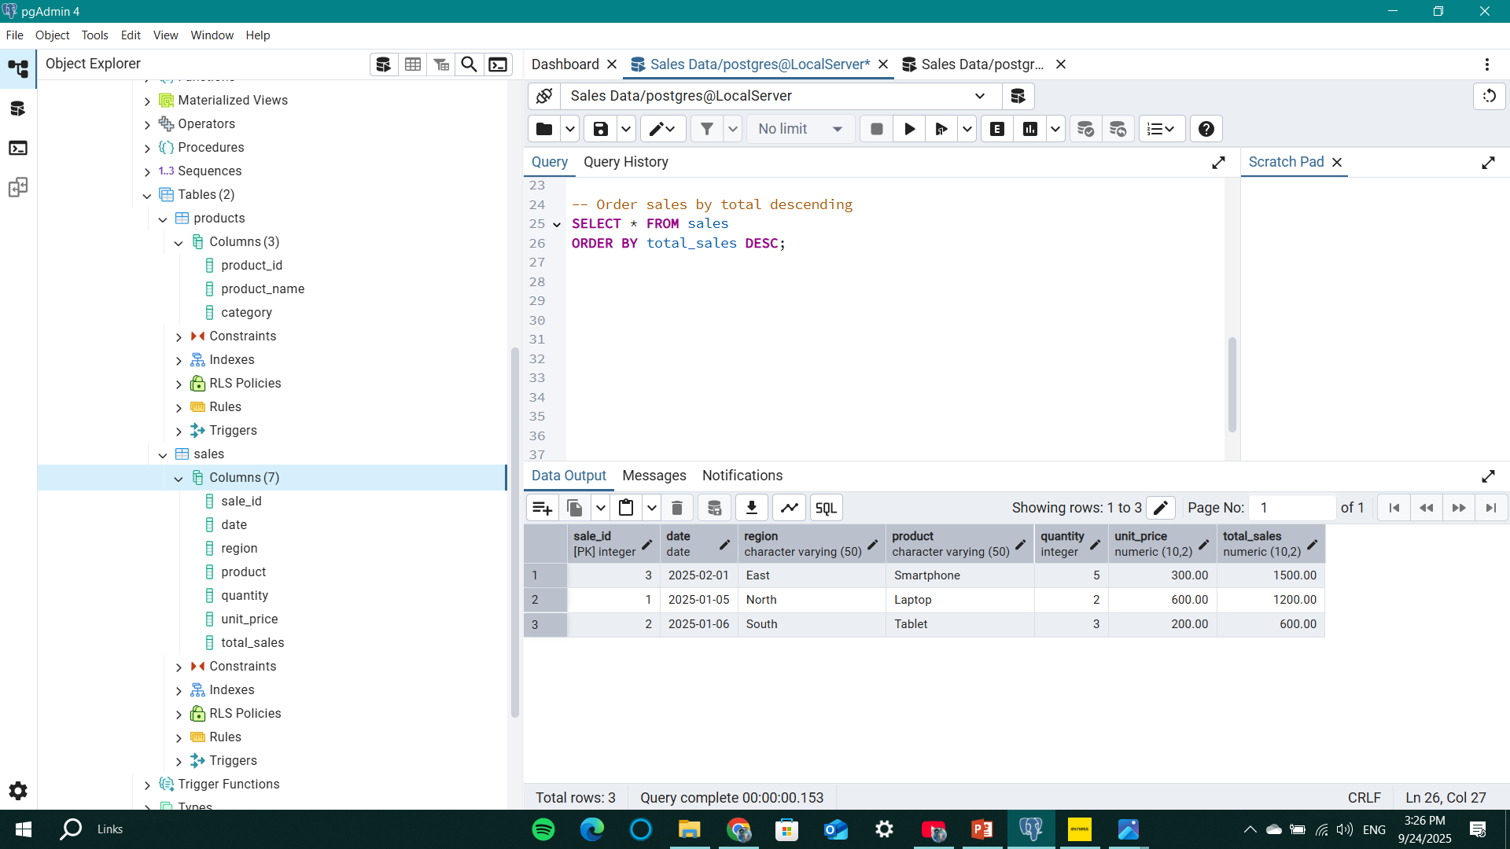

Step 6: UPDATE (Before & After)
-- Before update
SELECT * FROM sales WHERE sale_id = 2;
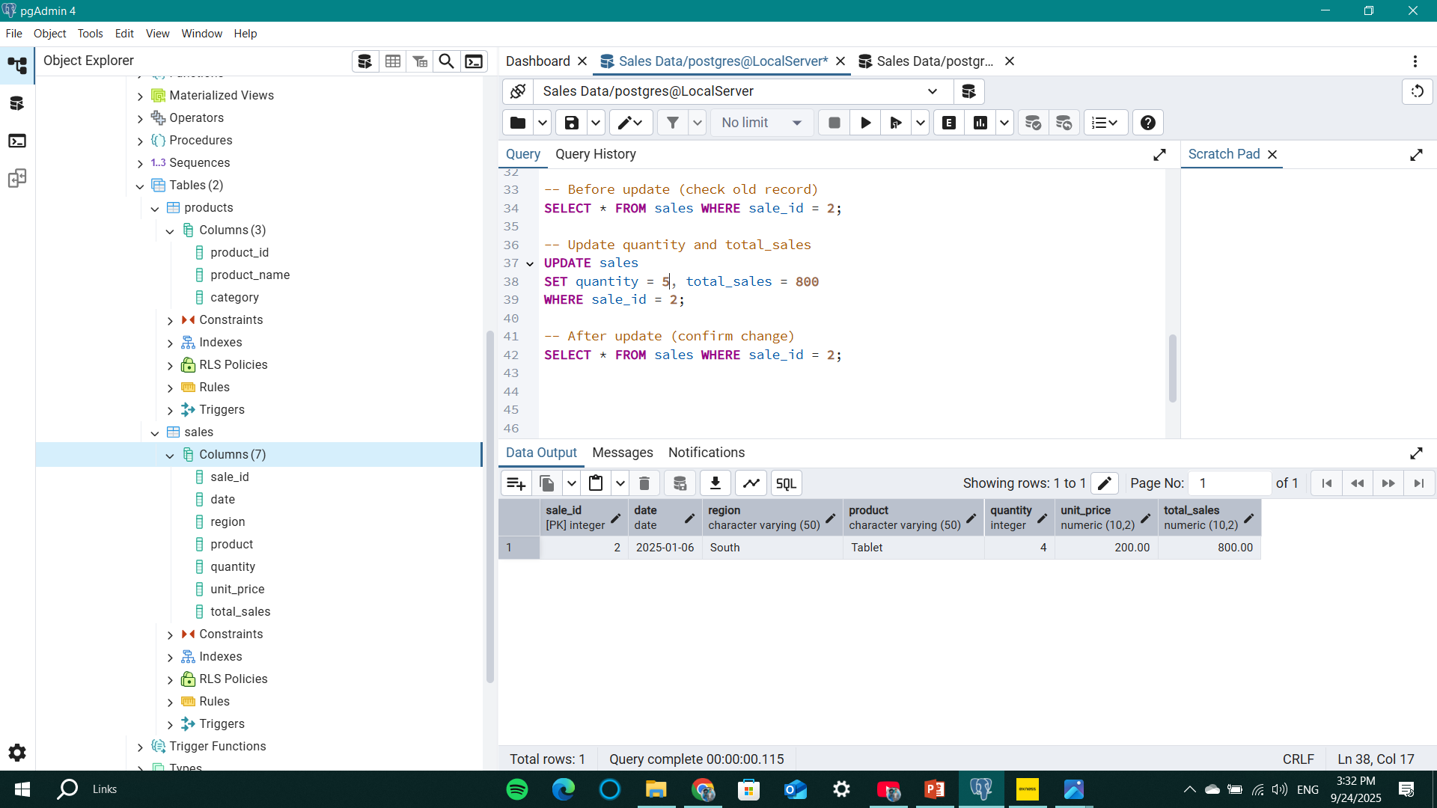
-- Update record
UPDATE sales
SET quantity = 4, total_sales = 800
WHERE sale_id = 2;

-- After update
SELECT * FROM sales WHERE sale_id = 2;

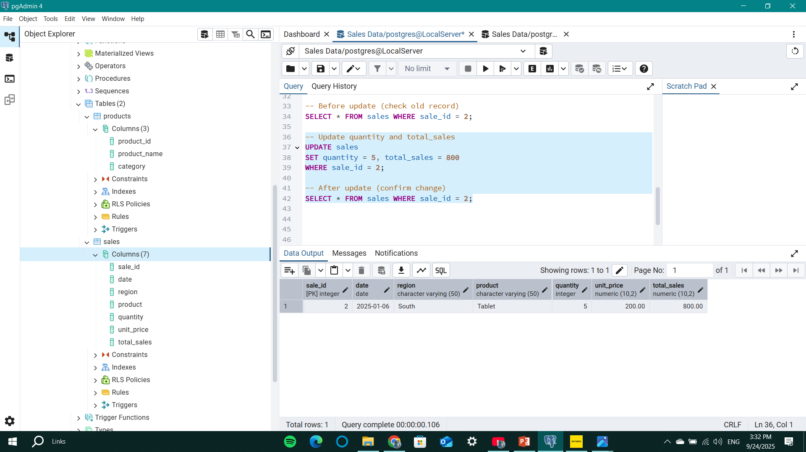

Step 7: DELETE (Before & After)
-- Before delete
SELECT * FROM sales WHERE region = 'East';
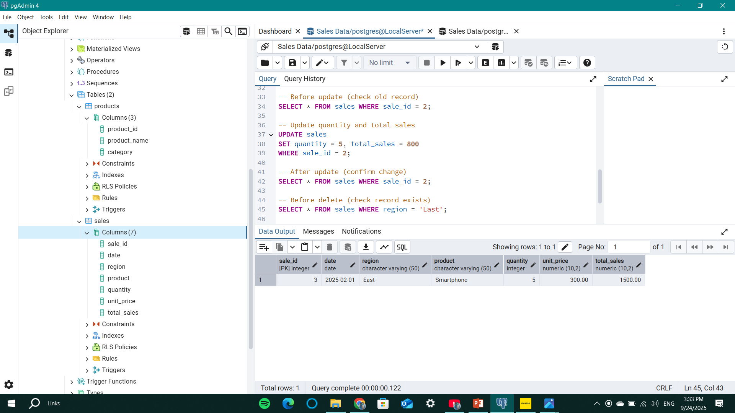
-- Delete record(s)
DELETE FROM sales WHERE region = 'East';

-- After delete
SELECT * FROM sales WHERE region = 'East';

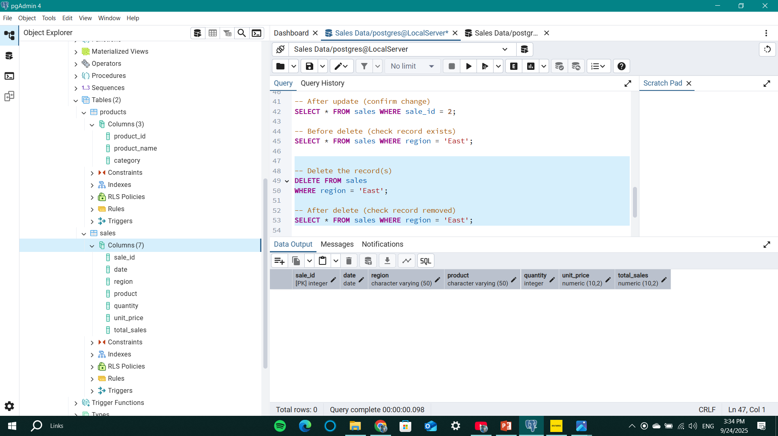

Step 8: GROUP BY with Aggregation
-- Total sales by region
SELECT region, SUM(total_sales) AS total_revenue
FROM sales
GROUP BY region;
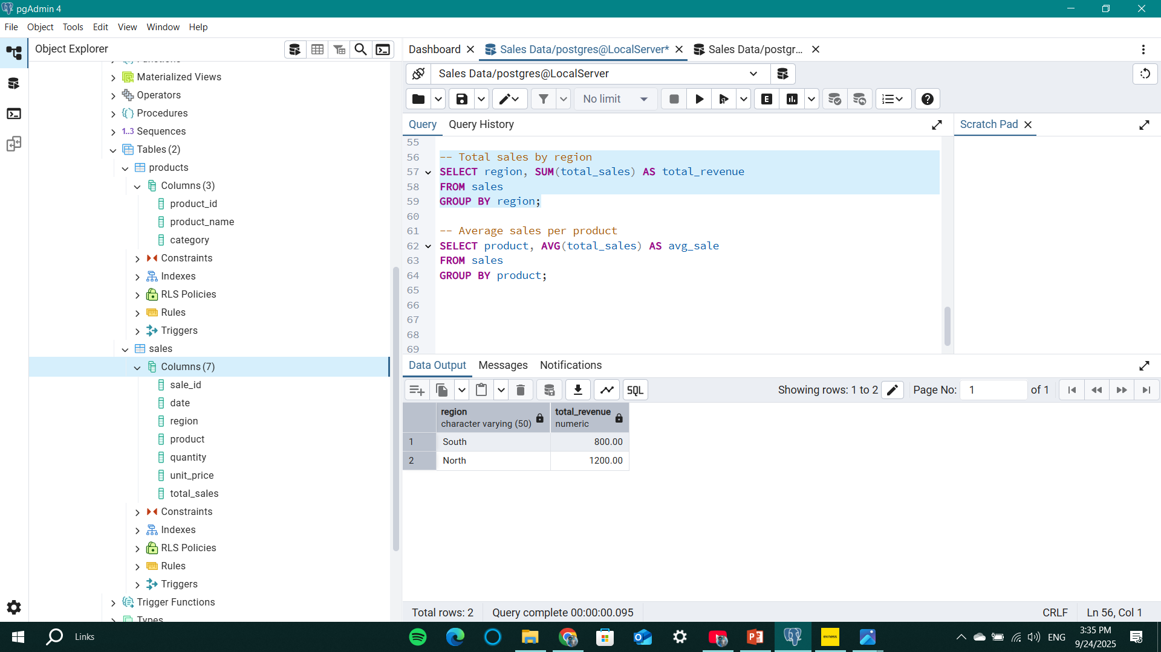

-- Average sales by product
SELECT product, AVG(total_sales) AS avg_sale
FROM sales
GROUP BY product;

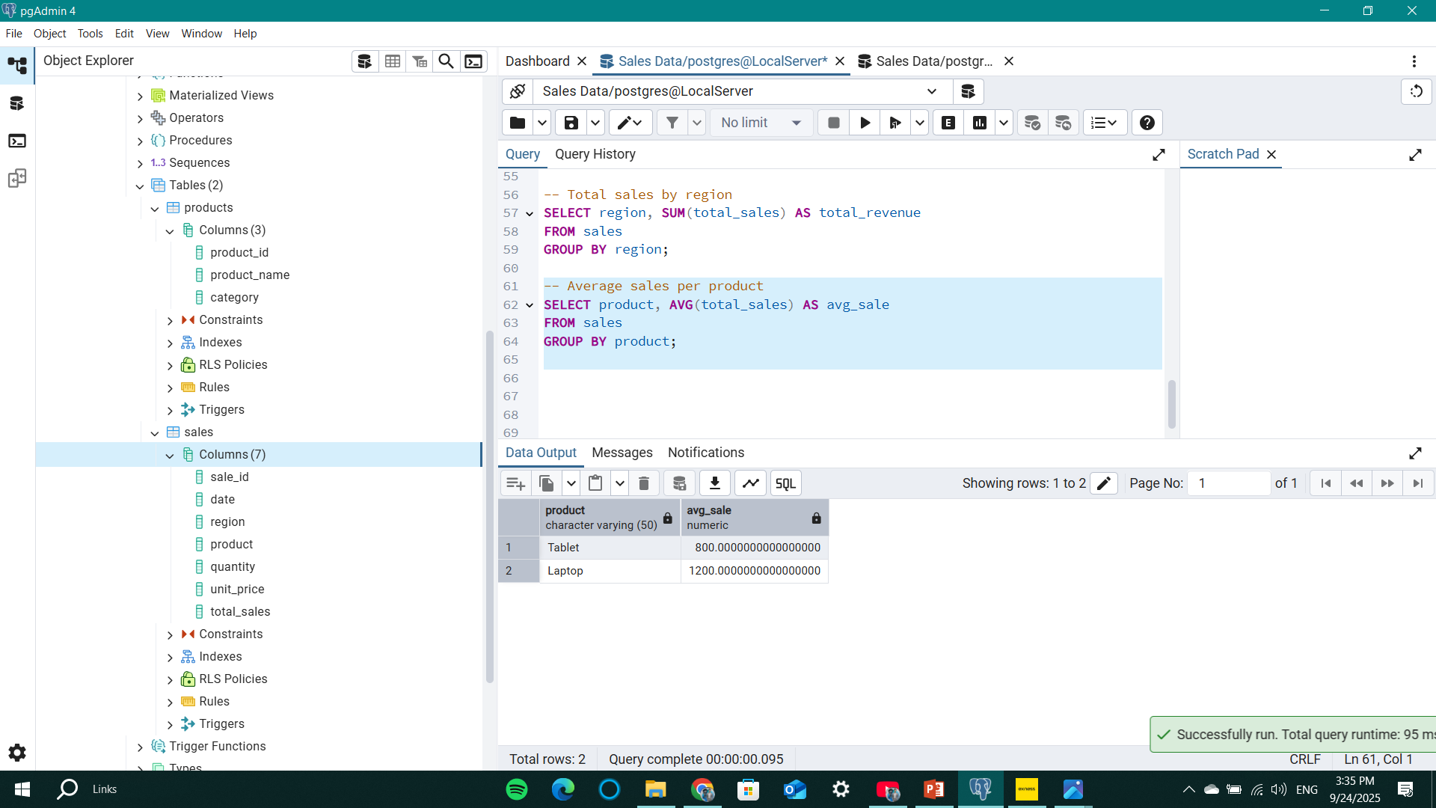

Step 9: JOIN Tables
SELECT s.sale_id, s.date, s.region, p.product_name, p.category, s.quantity, s.total_sales
FROM sales s
JOIN products p
ON s.product = p.product_name;
Sales table was joined with Products table.
Result shows dataset with product categories.
